**Following are the three observations based on the data analysis of Pymaceuticals:**

1. In the following graph of tumor response to treatment, we can see the response of four drugs. Where Infubinol, Ketapril and Placebo’s Tumor Volume response increases, the response of Capomulin decreases based on the increase of time.

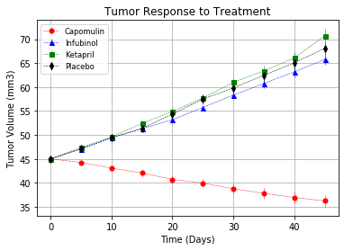

1. The following graph shows us the survival rate goes down as the days increase during treatment. The least amount of drop is of Capomulin.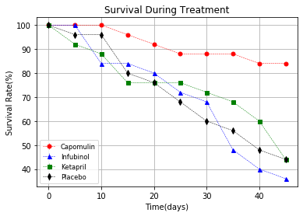
2. The Final observation is: Capomulin has -19% tumor change, infubinol has 46%, Ketapril has 57% and Placebo has 51% change over 45 day treatment.

